1.PLAIN TEXT TO CIPHER

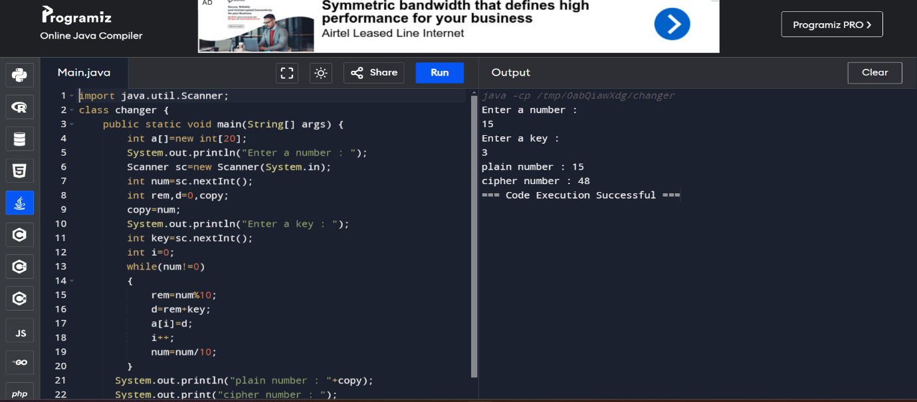

2.REVERSE NUMBER

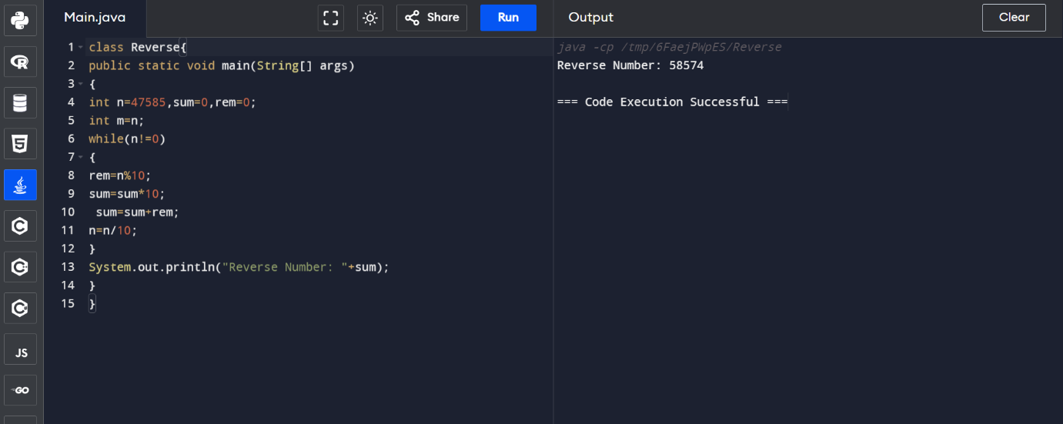

3.ARMSTRONG NUMBER

